Justin Sterlacci  
Internetworking  
Professor Cannistra  
January 28th, 2023

**Lab 1 Lab Report**

**Lab Description:**   
Introduction to how Cisco Packet Tracer will be used in Internetworking to show a network topography, as well as setting up a basic network incorporating several PC’s and switches.   
  
**Topography:**  
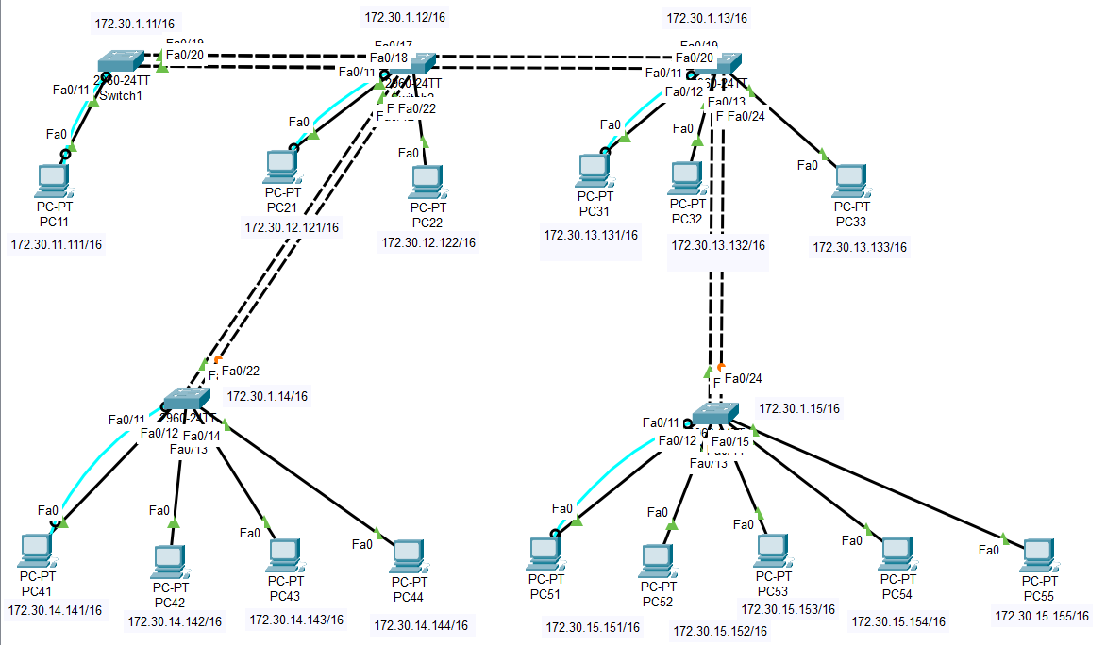  
  
Syntax:

CLI Command Description Mode of Cisco OIS

|  |  |  |
| --- | --- | --- |
| ping | Used to ping ip addresses from a PC. You can ping other PC’s or switches with this. | Windows CMD |
| Logging synchronous | Forces error messages to be on its own line, rather than interrupt a line that you’re typing on. | Console Line |
| Enable | Enter Privileged Mode | User Mode |
| Conf t | Enter Global Configurator Mode | Privileged Mode |
| Line con 0 | Enter the Console Line | Global Configurator Mode |
| Hostname | Used to name a switch or PC | Privileged Mode |
| Password | Used to set a password | Privileged Mode |
| Login | Used to require the password to utilize User Mode | Global Configurator Mode |
| Enable password | Used to set an unencrypted Privileged Password | Global Configurator Mode |
| Show ip interface brief (sh ip int brief) | Displays a brief list of all interfaces | Privileged Mode |

**Verification:**  
  
2.  
  
C) Verify PCs are able to reach the other PC’s and the Switches:  
Below is the ping commands checking the connectivity of different PCs, which is labeled with a Fig 1 next to it. In this case I connected to PC21, which is directly connected to Switch2. Below that, represented with Fig 2, I connected to Switch 5 to show the connection between switches. The Request timed out for the first connection as it was the first time reaching that switch, which will always cause a failure the first attempt. While it is feasible to test the connectivity to each host within the network manually, it can take a long time depending on the amount of hosts within the network. A way to improve the efficiency of testing connectivity is to set up an automated system to go through a list of IPs and test the connectivity until the list has been completed.   
  
*Fig 1*

*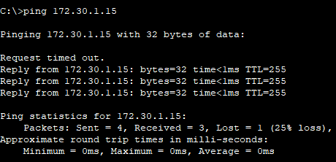Fig 2*

D) ARP Cache:

E) MAC address Table:

F) Redundant Switch to Switch Connections:  
While both ports are forwarding ports, because there are redundant ports it turns one of the two connections to a blocking connection rather than a forwarding connection. Both are not actively forwarding traffic.

**Conclusion:**

This lab, while seemed complex at first glance, was quite straightforward. The lab was a lot of repetition and getting used to setting up networks, using terminals, as well as just getting used to Cisco Packet Tracer. I did not run into any major issues.